Reading 23: Formal Semantics

# Exercise 1: Summarize

Formal definitions of programming languages use BNF, ASTs, Prolog interpreters, and natural semantics to cover basic expressions, variables, functions, and the differences between static and dynamic scoping.

# Exercise 2: Demonstrate & Explain

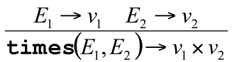

E1 evaluates to v1 as E2 evaluates to v2.

This means: The expression E1 * E2 evaluates to v1 * v2.

The rule states that if (E1) evaluates to (v1) and (E2) evaluates to (v2), then the expression (times(E1, E2)) evaluates to (v1 * v2). This means that the evaluation of the multiplication expression is determined by first evaluating its sub-expressions (E1) and (E2) to their respective values (v1) and (v2), and then multiplying these values. The rule ensures that the semantics of the multiplication operation are clear and consistent by breaking down the evaluation into its components and combining their results.

# Exercise 3: Inquire

How does static semantics affect natural semantics in terms of type checking?